LONG ISLAND HEALTH INFORMATION MANAGEMENT ASSOCIATION

Certificate of Membership

**«First_Name» «Last_Name»**

has been accepted as a member of the

LONG ISLAND HEALTH INFORMATION MANAGEMENT ASSOCIATION

and agrees to adhere to the LIHIMA code of ethics.

LIHIMA membership is effective for one year and expires on **12/31/2024**

**l**

**t**

**e**

**a**

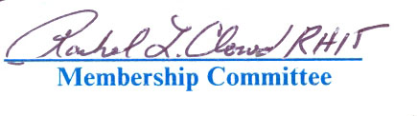



**m**

**t**

**M**

**I**

**n**

**M**

**f**

**o**

**B**

**r**

**E**

**o**

**n**

**M**

**a**

**n**

**V**

**a**

**A**

**g**

**L**

**e**

**U**

**m**

**E**

**e**

**D**

**n**

**t**

**M**

**A**

**E**

**s**

**s**

detach along dotted line

Thank You

for your commitment to quality health information, demonstrated through LIHIMA membership.







Name: **«First_Name» «Last_Name»**

Member Type: **«Status»**

Paid Thru: **12/31/24**

Membership Card



ID#: **«Member_»**